**Assignment sheet for IAM**

**Assignment 1 :- Create an IAM user with username of your own wish and grant**

**administrator policy.**

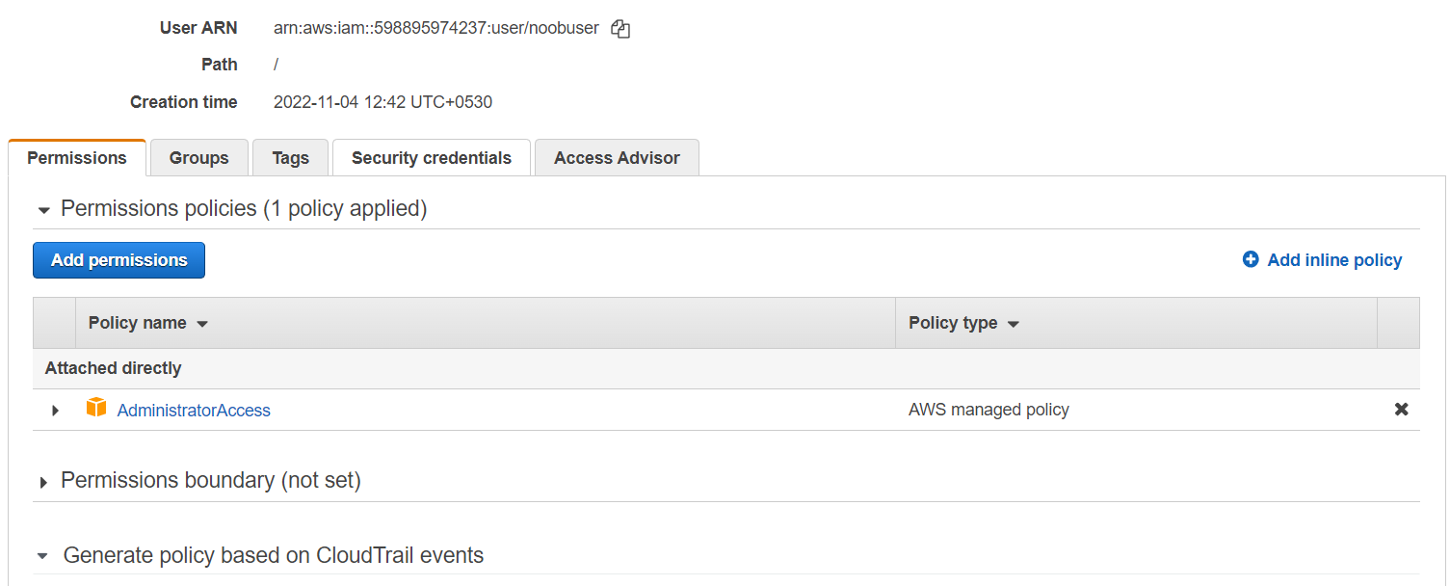

**Assignment 2 :- Hello students, in this assignment you need to prepare a**

**developers team of avengers.**

**- Create 3 IAM users of avengers and assign them in developer’s groups with**

**IAM policy.**

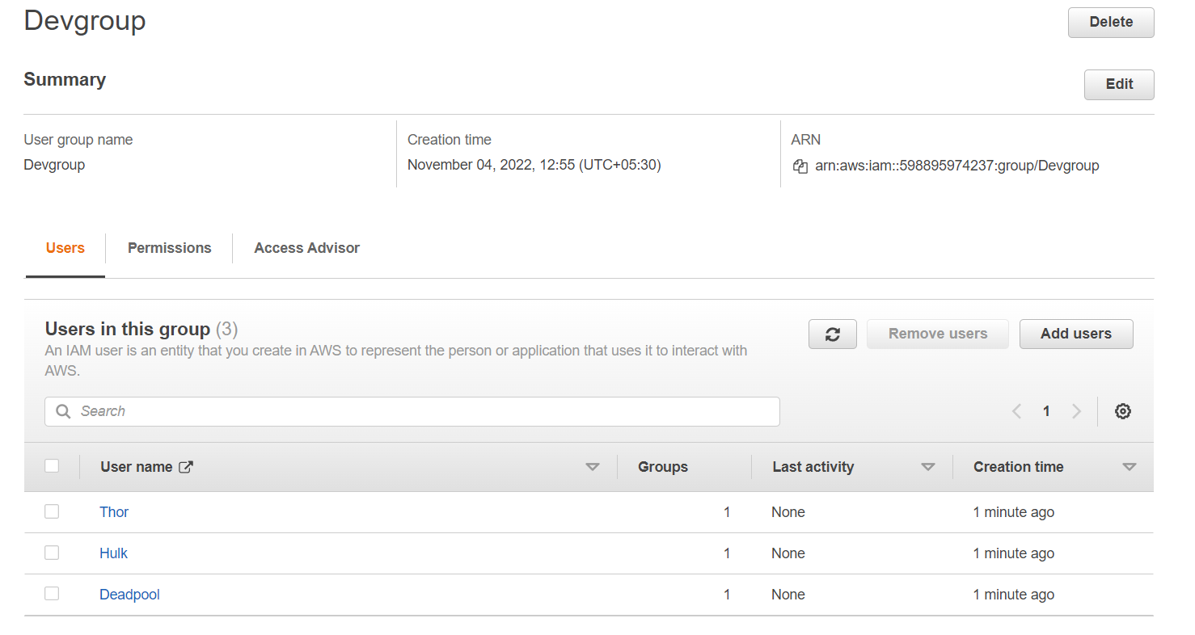

**Assignment 3 :- Define a condition in policy for expiration like**

**"DateGreaterThan": {"aws:CurrentTime":**

**"2020-04-01T00:00:00Z"},**

**"DateLessThan": {"aws:CurrentTime":**

**"2020-06-30T23:59:59Z"}**

**Define the span of 4 months as per your wish**

**Assignment 3 :- Prepare 15 authentic MCQ questions related to IAM.**

|  |  |  |  |  |  |  |  |  |  |
| --- | --- | --- | --- | --- | --- | --- | --- | --- | --- |
| 1 | How many maximum managed policies can be assigned to an IAM entity?   |  |  | | --- | --- | | (a) | 2 | | (b) | 5 | | (c) | 10 | | (d) | 20 | |
| 2 | How many maximum server certificates can be store in an AWS account?   |  |  | | --- | --- | | (a) | 20 | | (b) | 50 | | (c) | 100 | | (d) | 500 | |
|  |  |

|  |  |  |  |  |  |  |  |  |  |
| --- | --- | --- | --- | --- | --- | --- | --- | --- | --- |
| 3 | When you first create an Amazon Web Services (AWS) account, you begin with a single sign-in identity that has complete access to all AWS services and resources in the account. This identity is called:   |  |  | | --- | --- | | (a) | Root user | | (b) | Main user | | (c) | Super user | | (d) | None of these | |
|  |  |
| 4 | In addition to using IAM roles and policies or custom authorizers, you can use an ________ user pool to control who can access your API in Amazon API Gateway.   |  |  | | --- | --- | | (a) | Amazon S3 | | (b) | Amazon Cognito | | (c) | Amazon EBS | | (d) | All of these | |
|  |  |

|  |  |  |  |  |  |  |  |  |  |
| --- | --- | --- | --- | --- | --- | --- | --- | --- | --- |
| 5 | ______allows your HTTP backend to control and accept only requests originating from Amazon API Gateway, even if the backend is publicly accessible.   |  |  | | --- | --- | | (a) | Amazon Cognito | | (b) | Amazon S3 | | (c) | Client-Side SSL Certificates | | (d) | Amazon EBS | |
|  |  |
| 6 | Identify the wrong statement for AWS.   |  |  | | --- | --- | | (a) | When a storage device has reached the end of its useful life, AWS procedures include a decommissioning process | | (b) | UPS units provide back-up power in the event of an electrical failure for critical and essential loads in the facility | | (c) | Automatic fire detection and suppression equipment has been installed to reduce risk | | (d) | AWS allows its user to visit physical data centers so that user can trust on it   |  |  |  |  |  |  |  |  |  |  |  |  |  |  | | --- | --- | --- | --- | --- | --- | --- | --- | --- | --- | --- | --- | --- | --- | | 7 |  |  |  |  | AWS supports ______ types of policies.   |  |  | | --- | --- | | (a) | 4 | | (b) | 5 | | (c) | 6 | | (d) | 7 | | |  |  |  |  |  |  | | 8 |  |  |  |  | Which of these is not an IAM policy type?   |  |  | | --- | --- | | (a) | Smart policies | | (b) | Access control lists (ACLs) | | (c) | Session policies | | (d) | Organizations SCPs | | |  |  |  |  |  |  |  |  |  |  |  |  |  |  |  |  |  | | --- | --- | --- | --- | --- | --- | --- | --- | --- | --- | | 9 | Identify the wrong statement.   |  |  | | --- | --- | | (a) | IAM can provide shared access to the AWS account | | (b) | IAM is paid service in AWS | | (c) | IAM can provide granular permissions | | (d) | IAM supports multifactor authentication | | |  |  | | 10 | Names of IAM identities (users, roles, and groups):   |  |  | | --- | --- | | (a) | Must be unique within the AWS account | | (b) | Must be unique within the availability zone | | (c) | Must be unique within the region | | (d) | Must be unique within the AWS cloud whole | | |  |  |  |  |  |  |  |  |  |  |  |  |  | | --- | --- | --- | --- | --- | --- | --- | --- | --- | --- | | 11 | How many maximum groups can be created in an AWS account?   |  |  | | --- | --- | | (a) | 25 | | (b) | 50 | | (c) | 100 | | (d) | 200 | | |  |  | | 12 | How many maximum users can be created in an AWS account?   |  |  | | --- | --- | | (a) | 2000 | | (b) | 5000 | | (c) | 8000 | | (d) | 10000 | | |  |  |  |  |  |  |  |  |  |  |  |  |  | | --- | --- | --- | --- | --- | --- | --- | --- | --- | --- | | 13 | How many maximum roles can be created in an AWS account?   |  |  | | --- | --- | | (a) | 200 | | (b) | 300 | | (c) | 400 | | (d) | 500 | | |  |  | | 14 | An IAM user cannot be a member of more than __ groups.   |  |  | | --- | --- | | (a) | 10 | | (b) | 20 | | (c) | 50 | | (d) | 100 | | |  |  |  |  |  |  |  |  |  |  |  |  |  | | --- | --- | --- | --- | --- | --- | --- | --- | --- | --- | | 15 | How many maximum access keys can be assigned to an IAM user?   |  |  | | --- | --- | | (a) | 1 | | (b) | 2 | | (c) | 3 | | (d) | 4 | | | |

**Assignment 4** :- Launch your linux instance in IAM and update your machine

